

# Practices for Secure Software Report

Table of Contents

Document Revision History 3

Client 3

Instructions 3

Developer 4

1. Algorithm Cipher 4

2. Certificate Generation 4

3. Deploy Cipher 4

4. Secure Communications 4

5. Secondary Testing 4

6. Functional Testing 4

7. Summary 4

8. Industry Standard Best Practices 4

## Document Revision History

| **Version** | **Date** | **Author** | **Comments** |
| --- | --- | --- | --- |
| **1.0** | **6-23-2024** | **Alex Baires** |  |

## Client



## Developer

Alex Baires

## Algorithm Cipher

As a growing financial institution, Artemis Financial is responsible for safeguarding consumer information and communication. While the industry standard is SHA-256, I recommend future-proofing Artemis Financials’ software using the SHA-3-384 algorithm.

**History and Current State of Encryption Algorithms**

In 2017, SHA-1 was officially cracked through a collision attack by Google researchers, negating the cipher’s security. The NIST had already recommended switching to the newer SHA-2 family, and the attack completed this process. Unfortunately, Grimes (2018) writes that it is only a matter of time before SHA-256 is cracked because several attacks have whittled down SHA-2’s effective protection to 2^37 computational operations (initially, it would take 2^128 operations to find a collision). SHA-2 utilizes an algorithm similar to SHA-1 but with the same cryptographic flaws. Its saving grace is its more considerable hash length (Grimes, 2018). However, an experiment conducted by Huang et al. (2022) shows that a practical collision attack on a 4-round modification of SHA-3-384 using a deduce-and-sieve algorithm is practical and results in a near-collision by only 4 bits. A well-funded adversary with more computing power may be able to find a collision for this particular reduced-round version (Huang et al., 2022). However, this does not lessen the security of the full 24-round SHA-3-384, as the data goes through another 20 rounds of permutation before becoming a hash value.

**Cryptography**

A cipher algorithm converts plain text into illegible cipher text. A key lets one decode the ciphertext into the original plaintext. A symmetric key algorithm utilizes one shared key to encrypt or decrypt the cipher text. An asymmetric key has two keys: a private and a public key. The private key is kept secret, while the public key is shared. Any data encrypted by one key can only be decrypted by the other. The SHA-3-384 algorithm is neither asymmetric nor symmetric. It is considered a one-way hash function that takes a variable-sized input and generates a fixed-length output or digest. The benefit of a one-way hash function is that any modification to the input results in a modified hash ciphertext. If one finds the cipher text, working backward to retrieve the original plaintext data is impossible (*Cryptography Concepts,* 2024).

Random numbers are essential in cryptography because they generate the keys used by any cryptographic algorithm cipher. Without this randomness, keys are easily predictable and conducive to being broken by attackers. Entropy is the amount of chaos in a system, and a secure system strives for plenty of entropy when generating a random number seed (Sidhpurwala, 2019). A paper written by the SHA-3-384 creators states that other “sponge” algorithms in the Keccak family with smaller lengths can be used as a CPRNG.

**SHA-3-384 Overview**

SHA-3-384 is the next-generation secure hash algorithm released by NIST on August 5, 2015. Its hash function is referred to as a “sponge function” and has absorption and squeeze phases. During the absorption phase, input data is divided into 832-bit blocks and checked, and any small remainder blocks are padded to a size that is the multiple of SHA-3's rate. In our case, this would be a multiple of 832. After this, several permutations occur that generate a message digest of 384 bits. Unlike past SHA algorithms, SHA-3-384 is based on the Keccak algorithm and is mathematically and cryptographically different than previous designs (Akiya et al., 2021; Anand, 2019; Grimes, 2018).

## Certificate Generation

Artemis.cer generated:

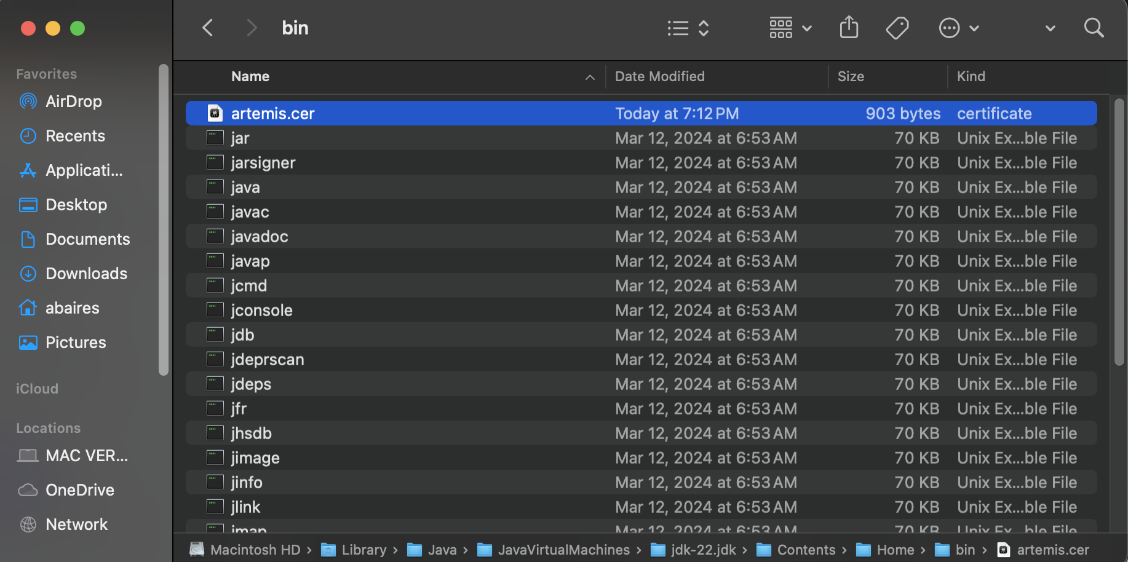

Artemis.cer printout:

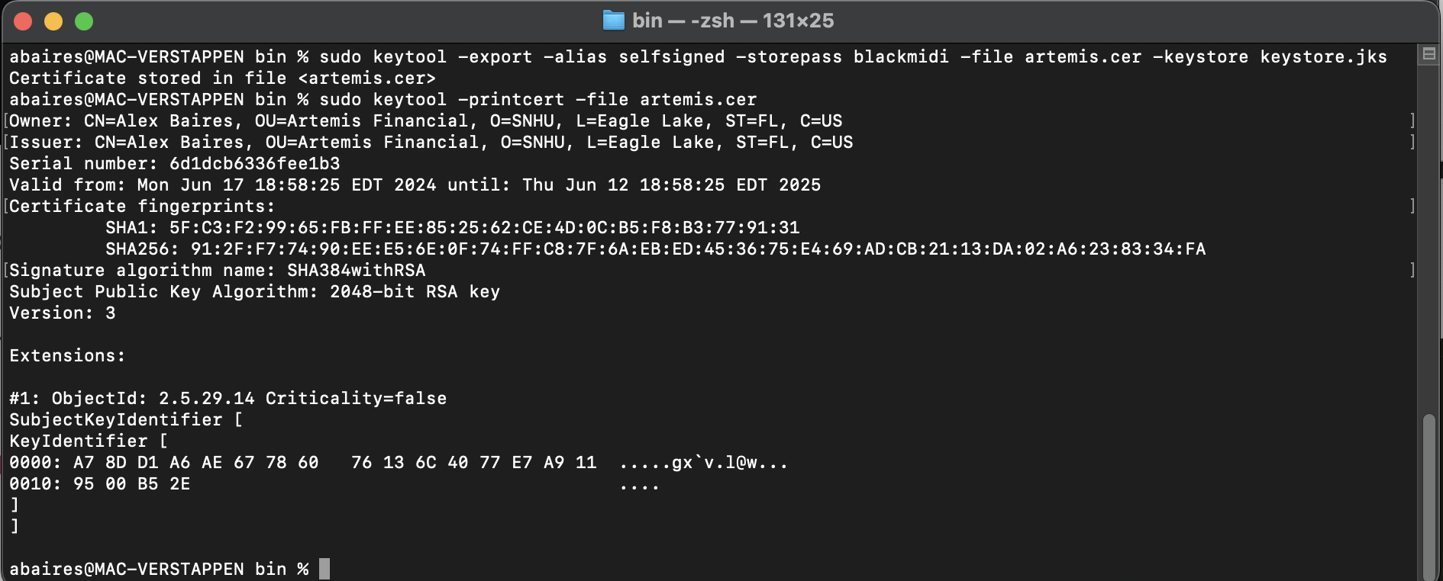

Artemis.cer in macOS Keychain Access (for verification):

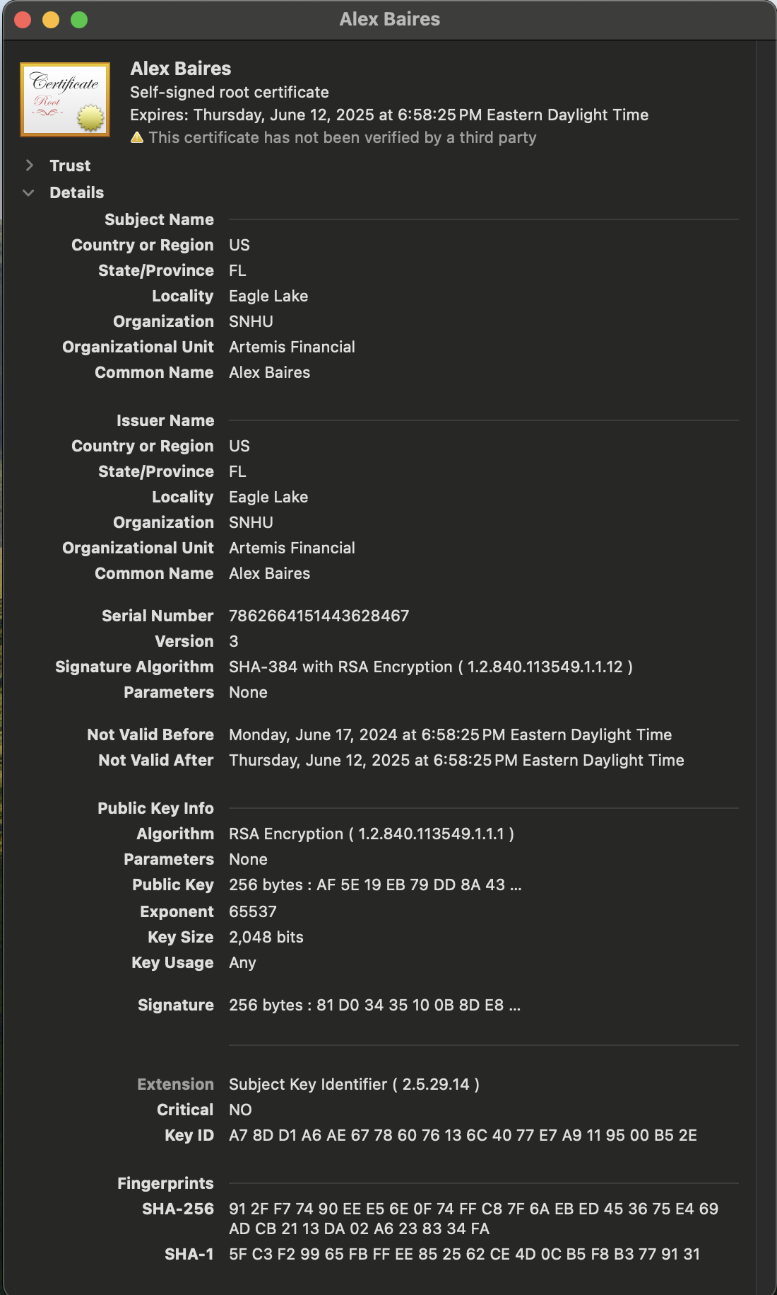

Updated Application.properties with new self-signed certificate placed in Resources:

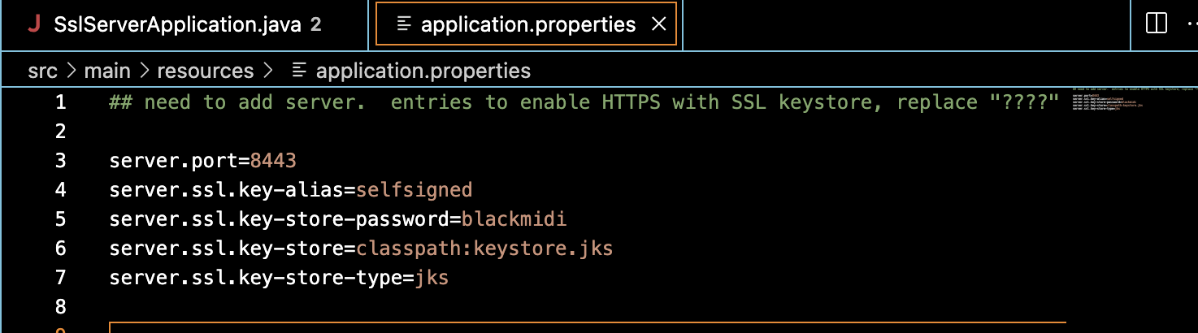

**Viewing Self Signed Certificate when Connecting to LocalHost in Safari:**

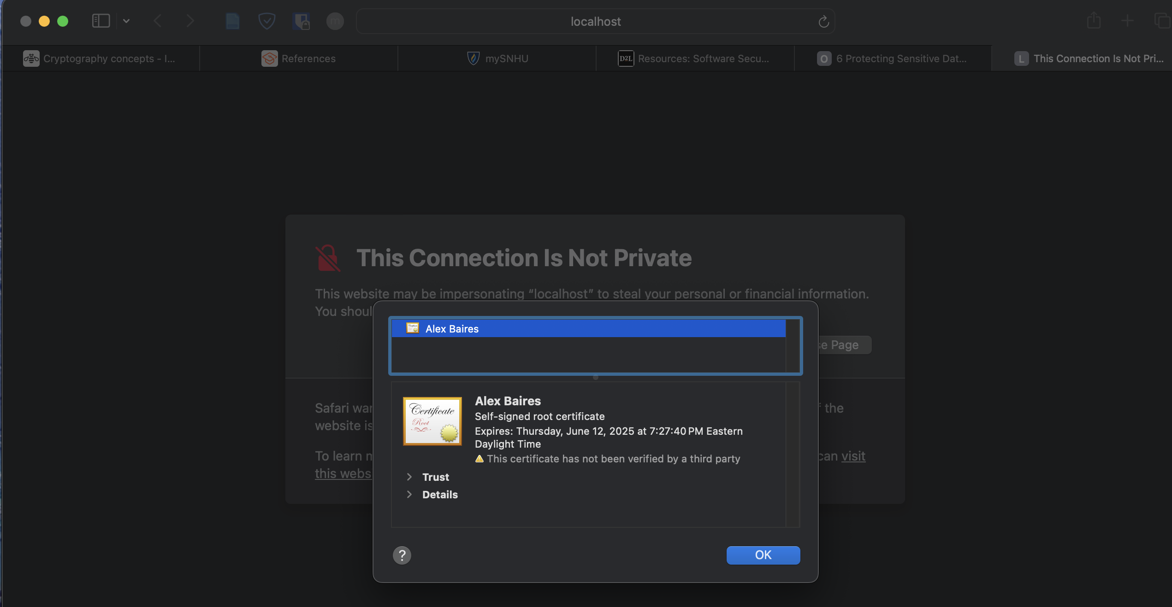

## Deploy Cipher

**Initial Cipher Code Implementation:**

bytesToHex()

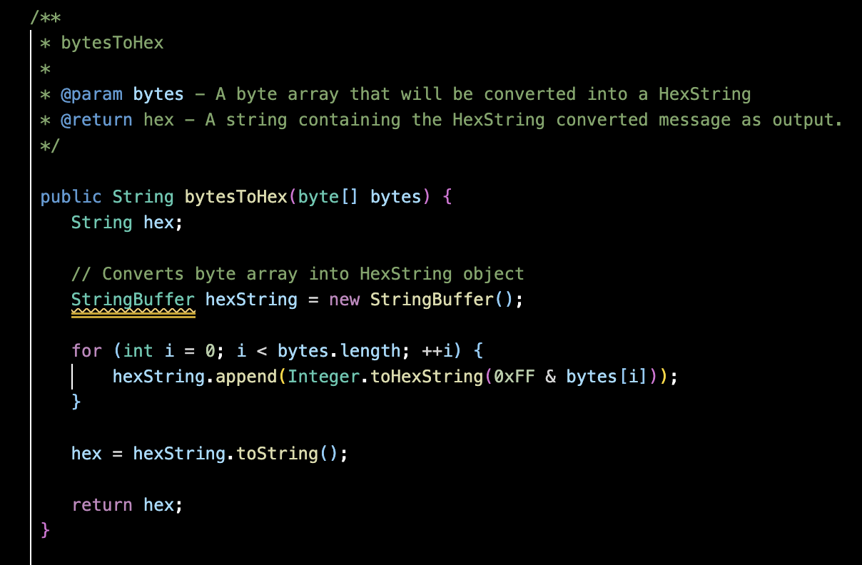

generateCheckSum()

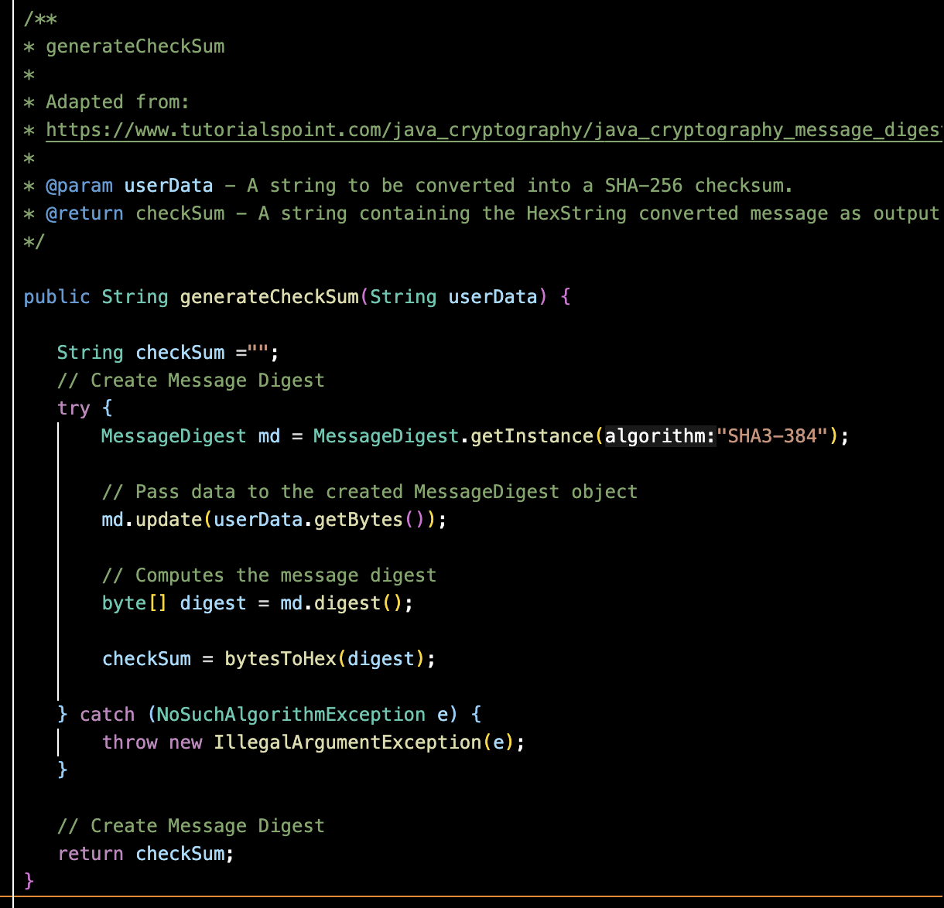

**Static Data String with Converted Checksum Value in Browser:**

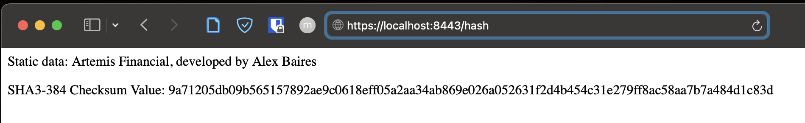

## Secure Communications

Insert a screenshot below of the web browser that shows a secure webpage.



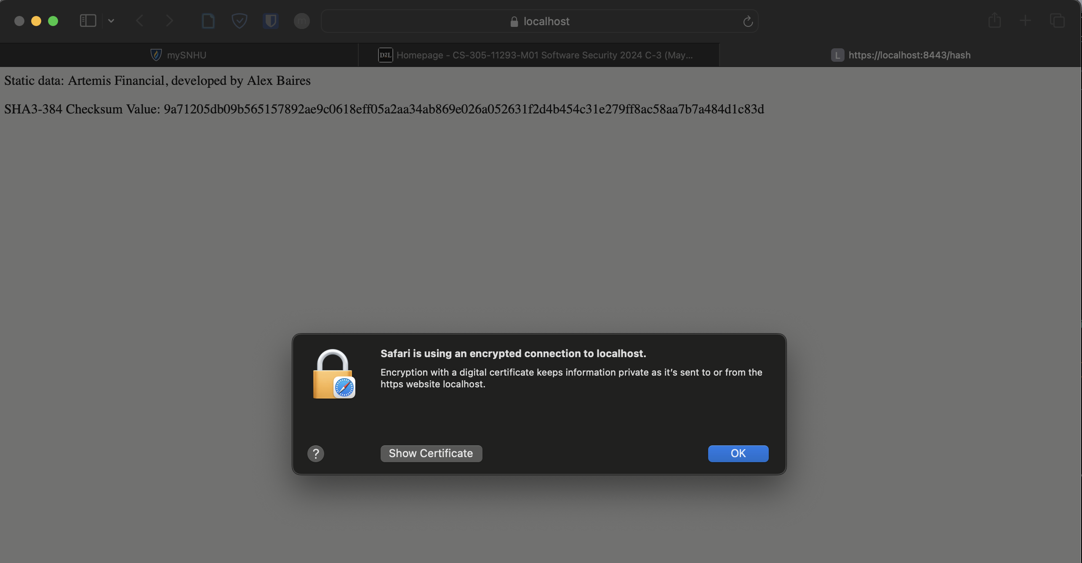

## Secondary Testing

Insert screenshots below of the refactored code executed without errors and the dependency-check report.

Refactored SslServerApplication.java:

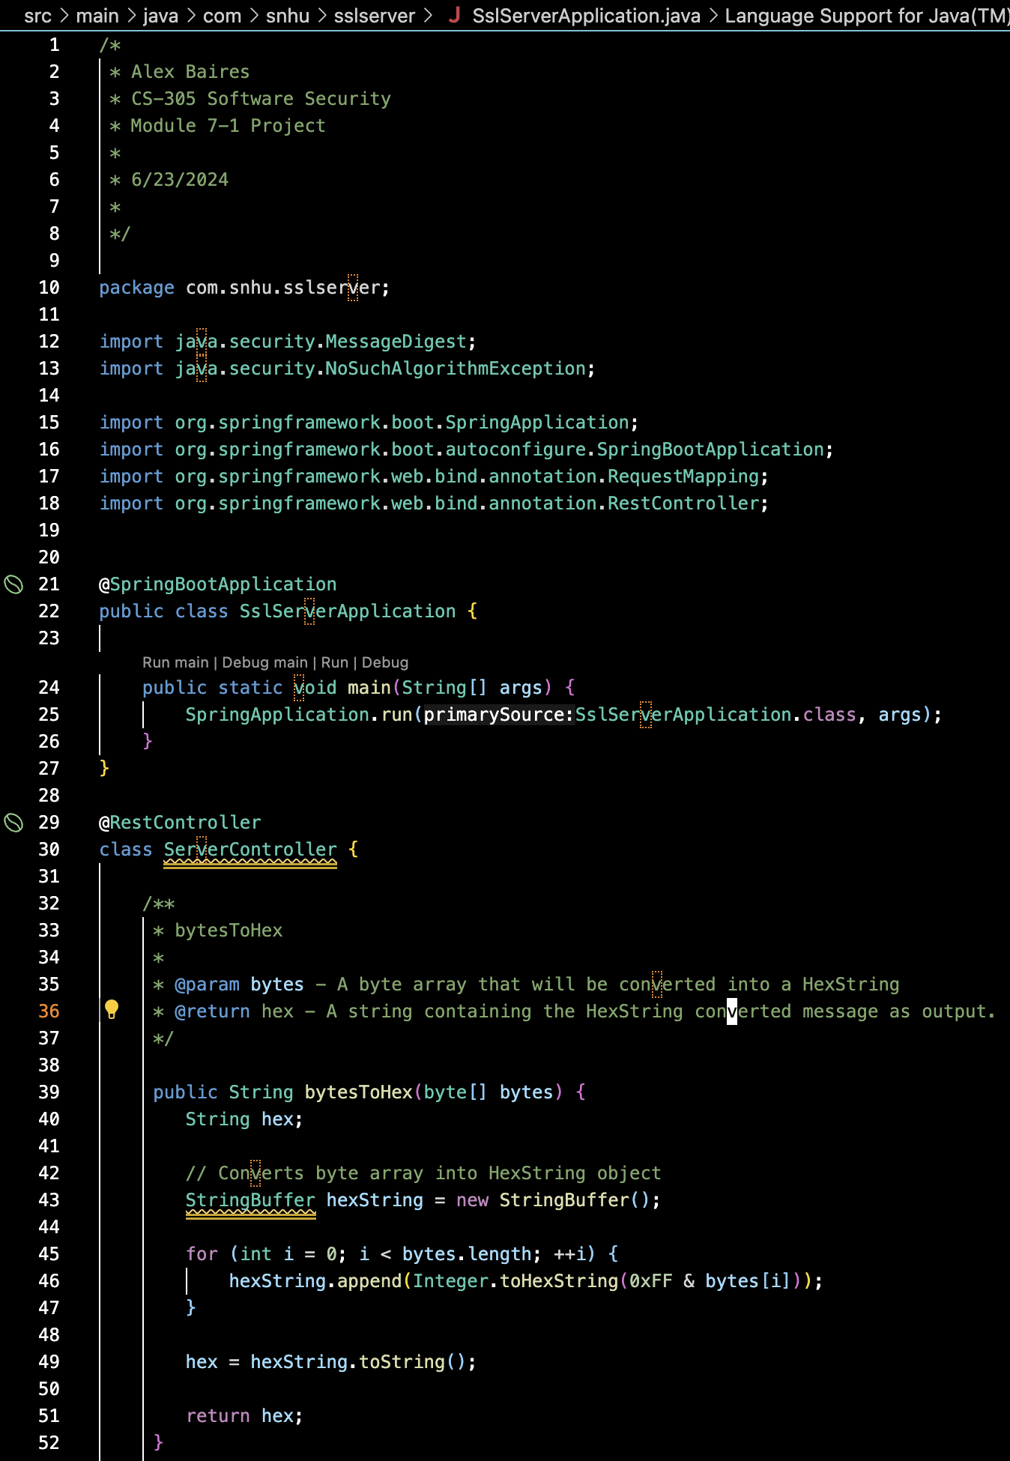

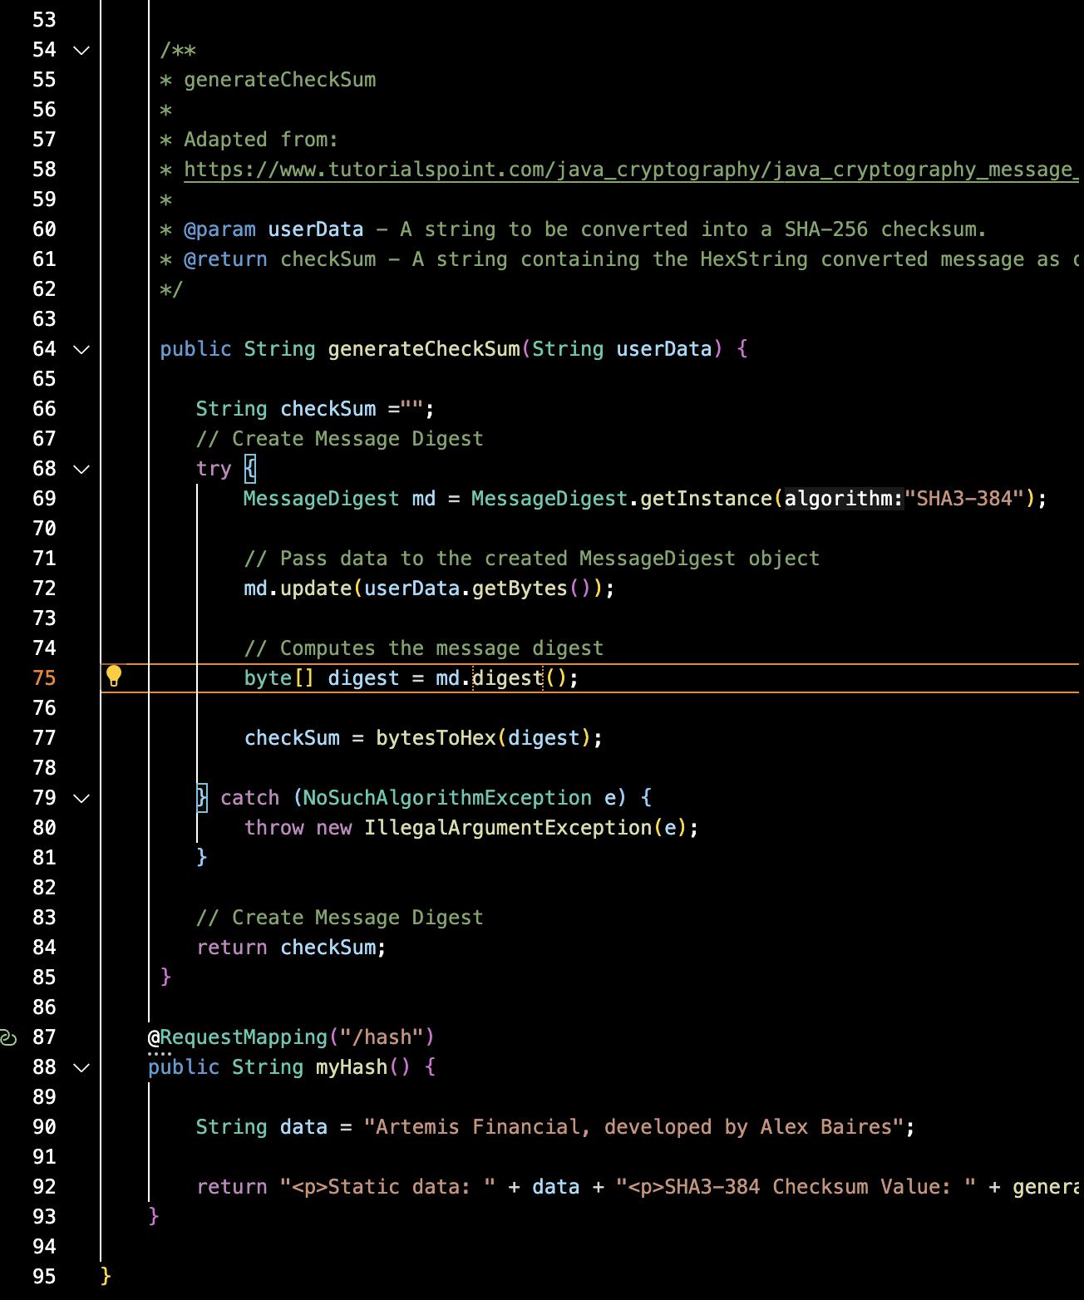

Initial pom.xml (the red highlight is a vulnerability detected by VS Code’s Red Hat Dependency Analyzer), pom.xml was also updated with latest 9.2.0 OWASP Dependency Check.

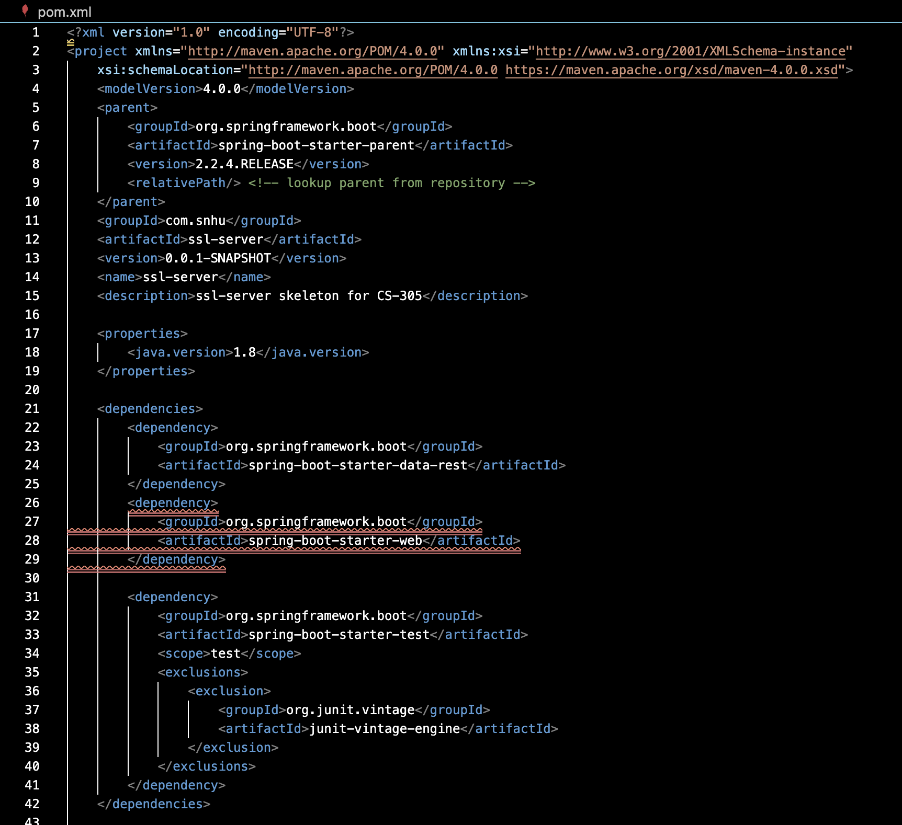

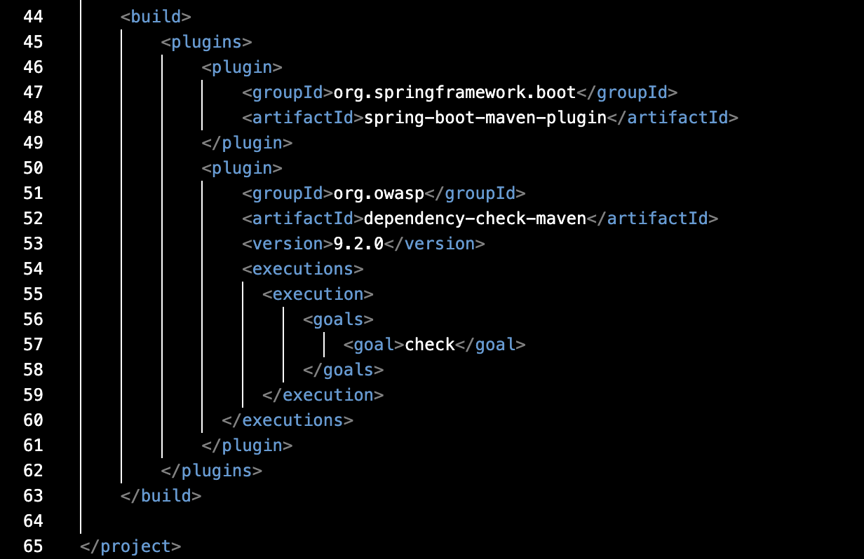

Refactored SslServerApplication.java Running in Terminal:

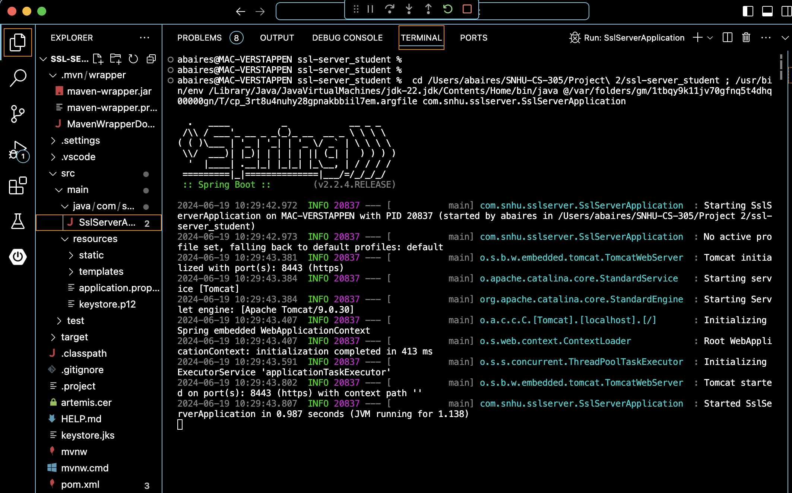

Initial Dependency-Check:

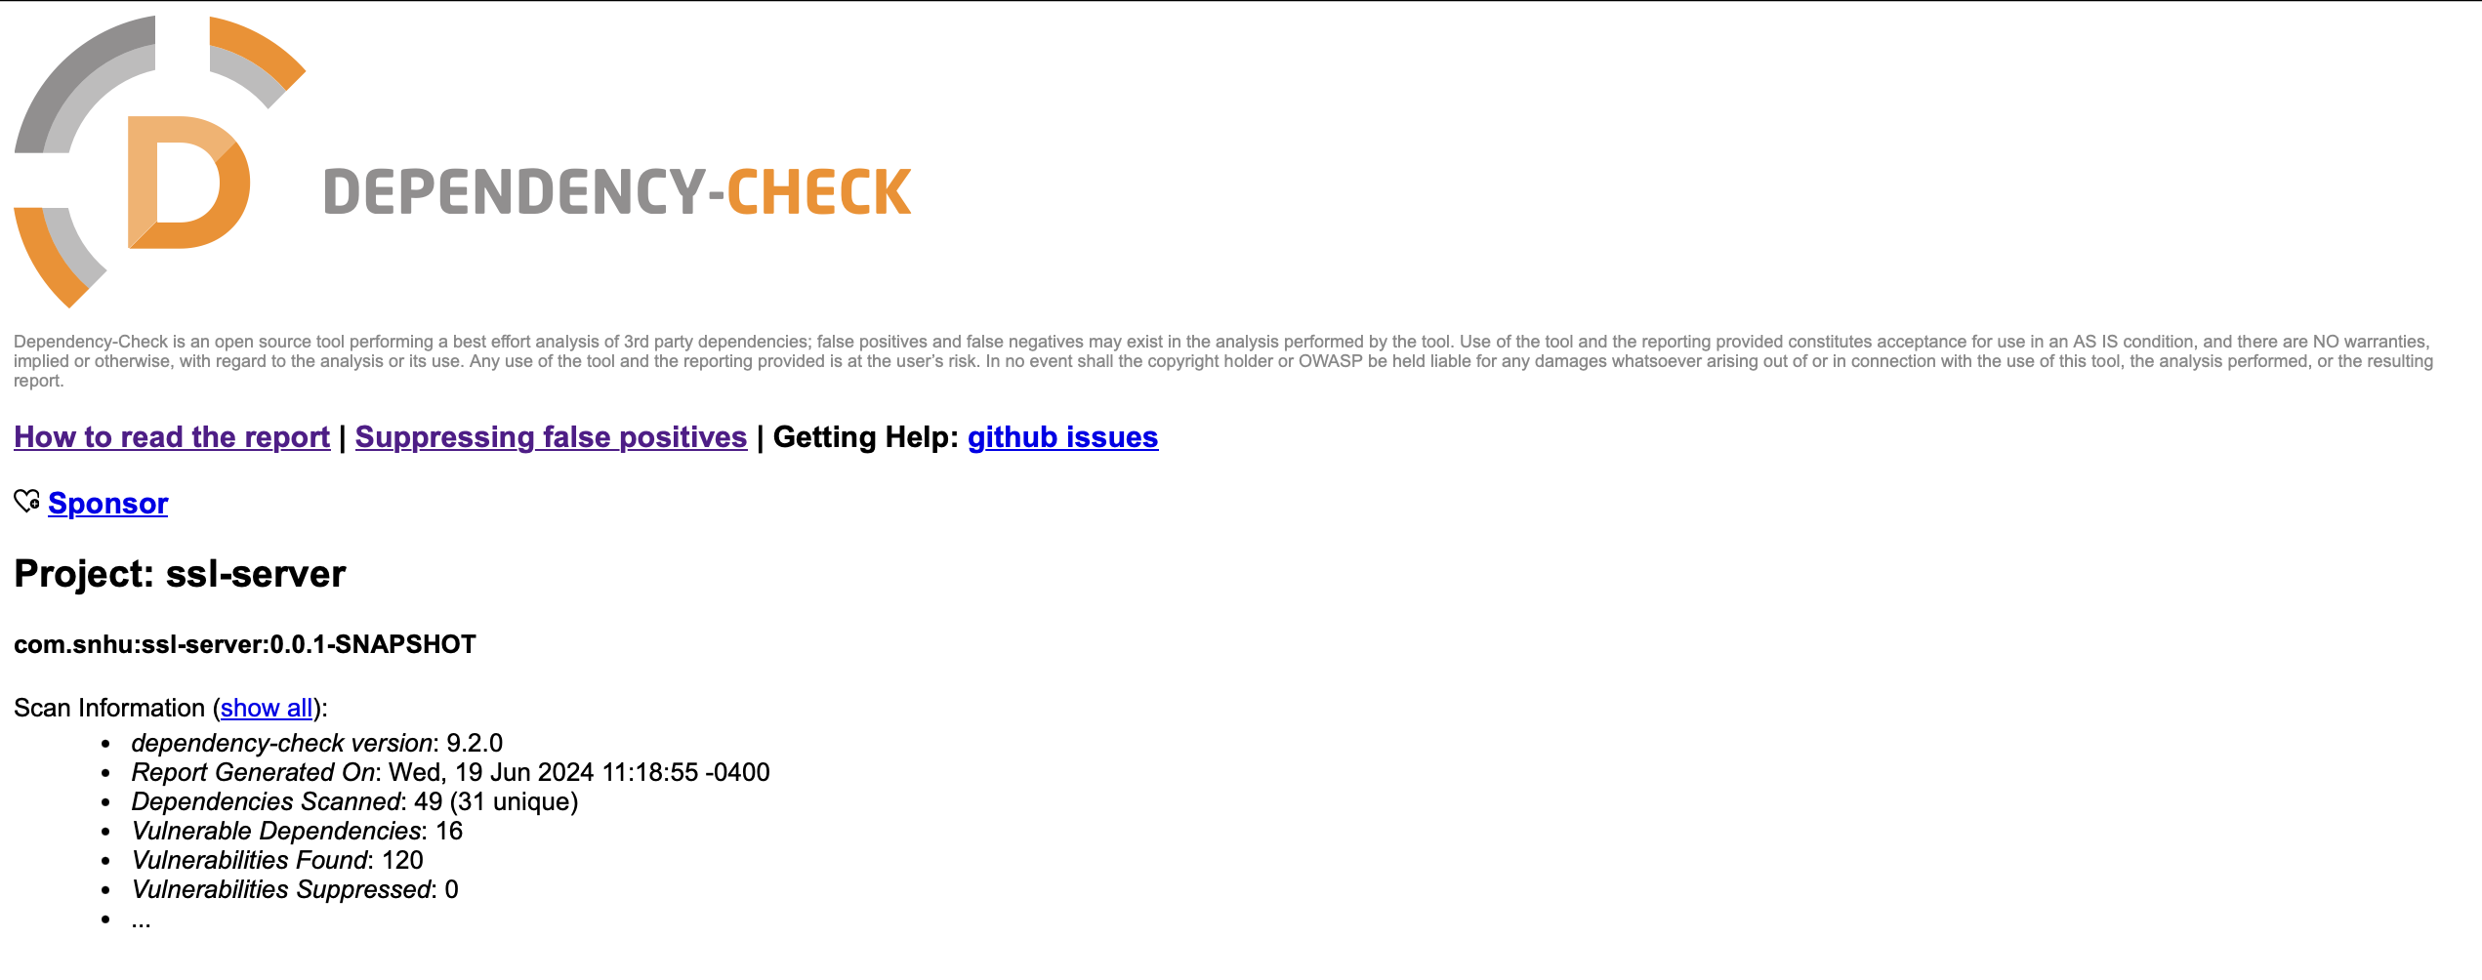

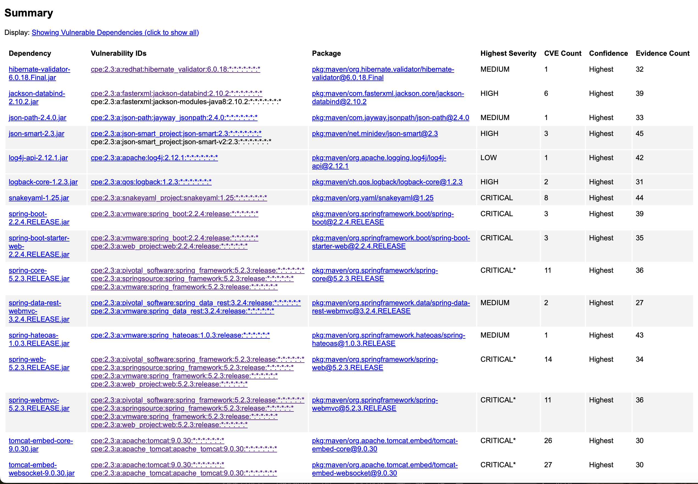

mvn dependency:tree command – Shows all dependencies in the project

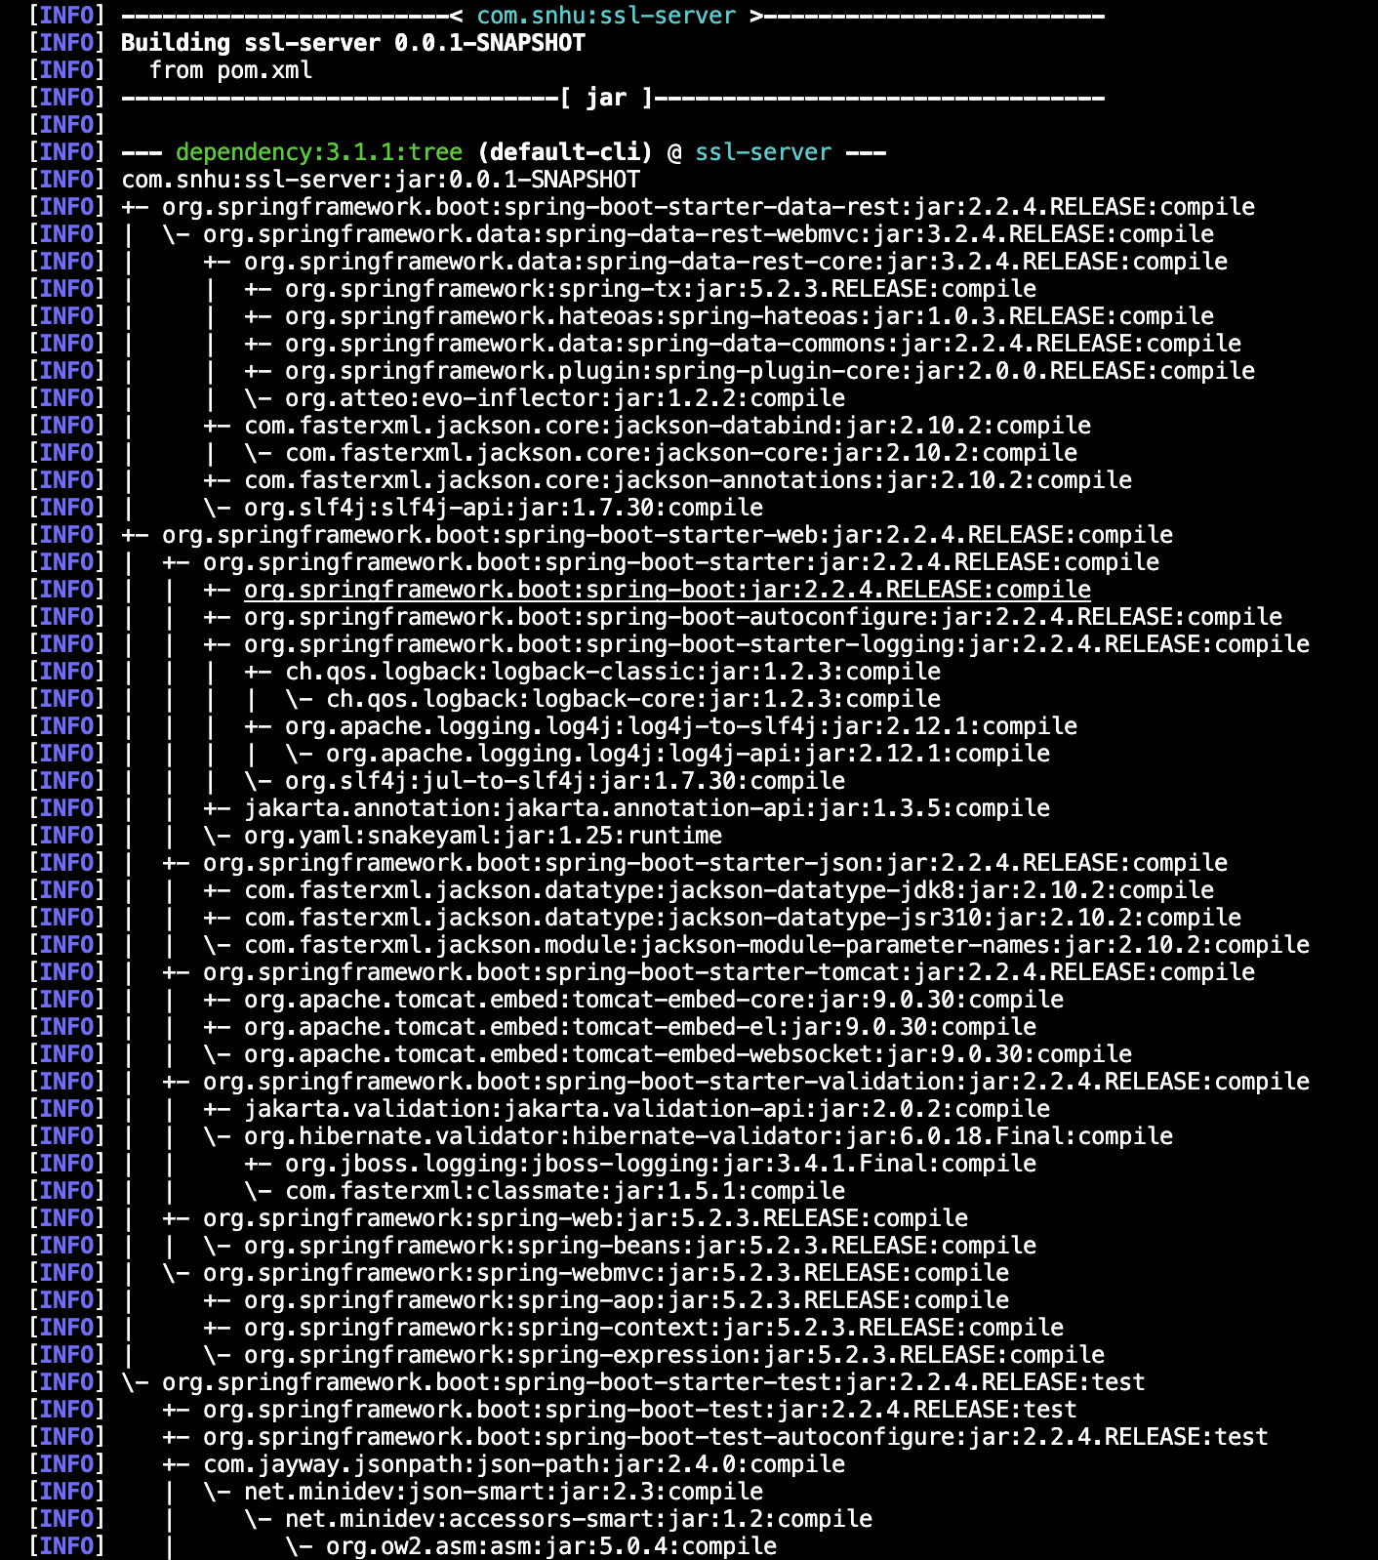

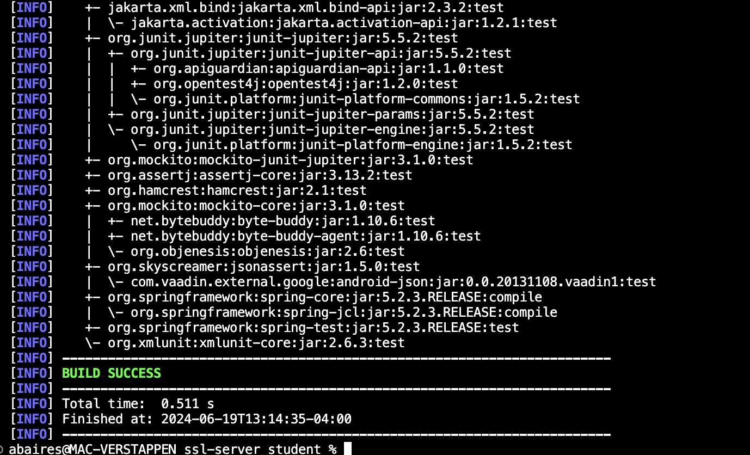

mvn versions:display-dependency-updates command – Shows all available updates to dependencies (truncated screenshot)

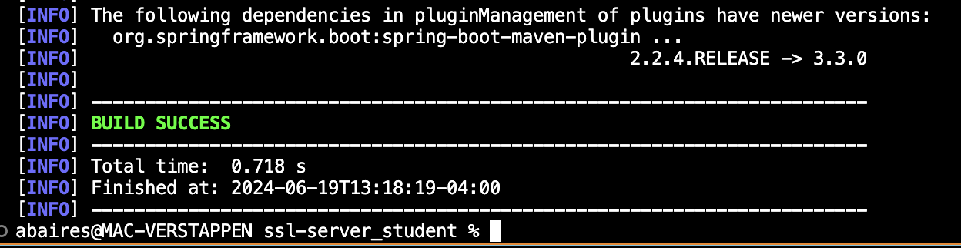

Updated to version 3.0.13 because this is the latest Spring Boot version that supports Java 1.8.

Reran Dependency-Check with Spring Boot 3.0.13:

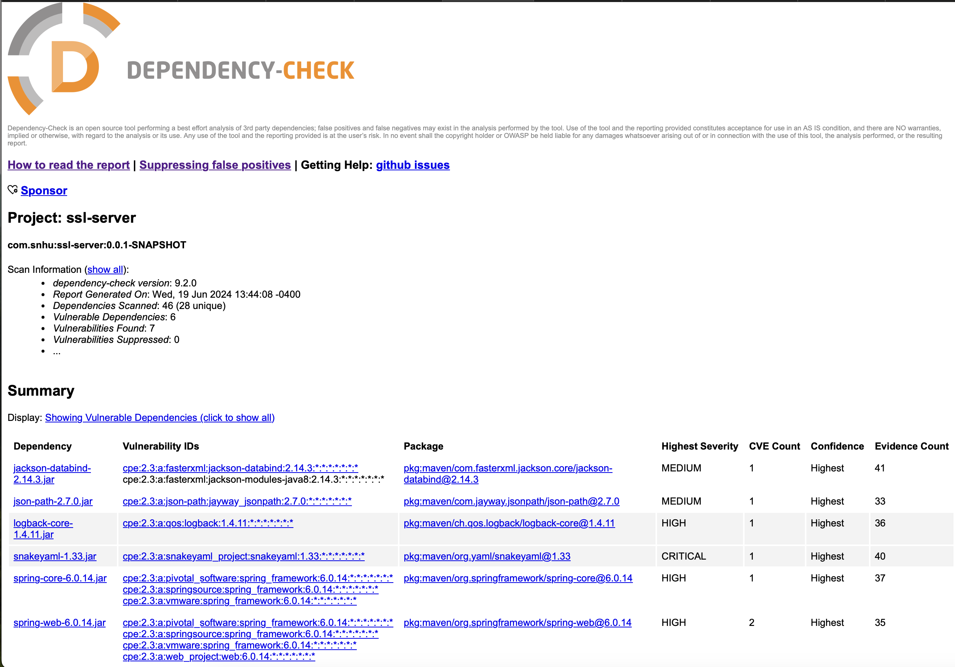

Added <DependencyManagement> section to pom.xml to have Spring call for specific sub-dependencies such as Jackson-databind, json-path, logback-core, logback-classic, snakeyaml, spring-core, spring-web. These dependencies were found by cross-referencing the dependency-check vulnerabilities with MVNRepository.

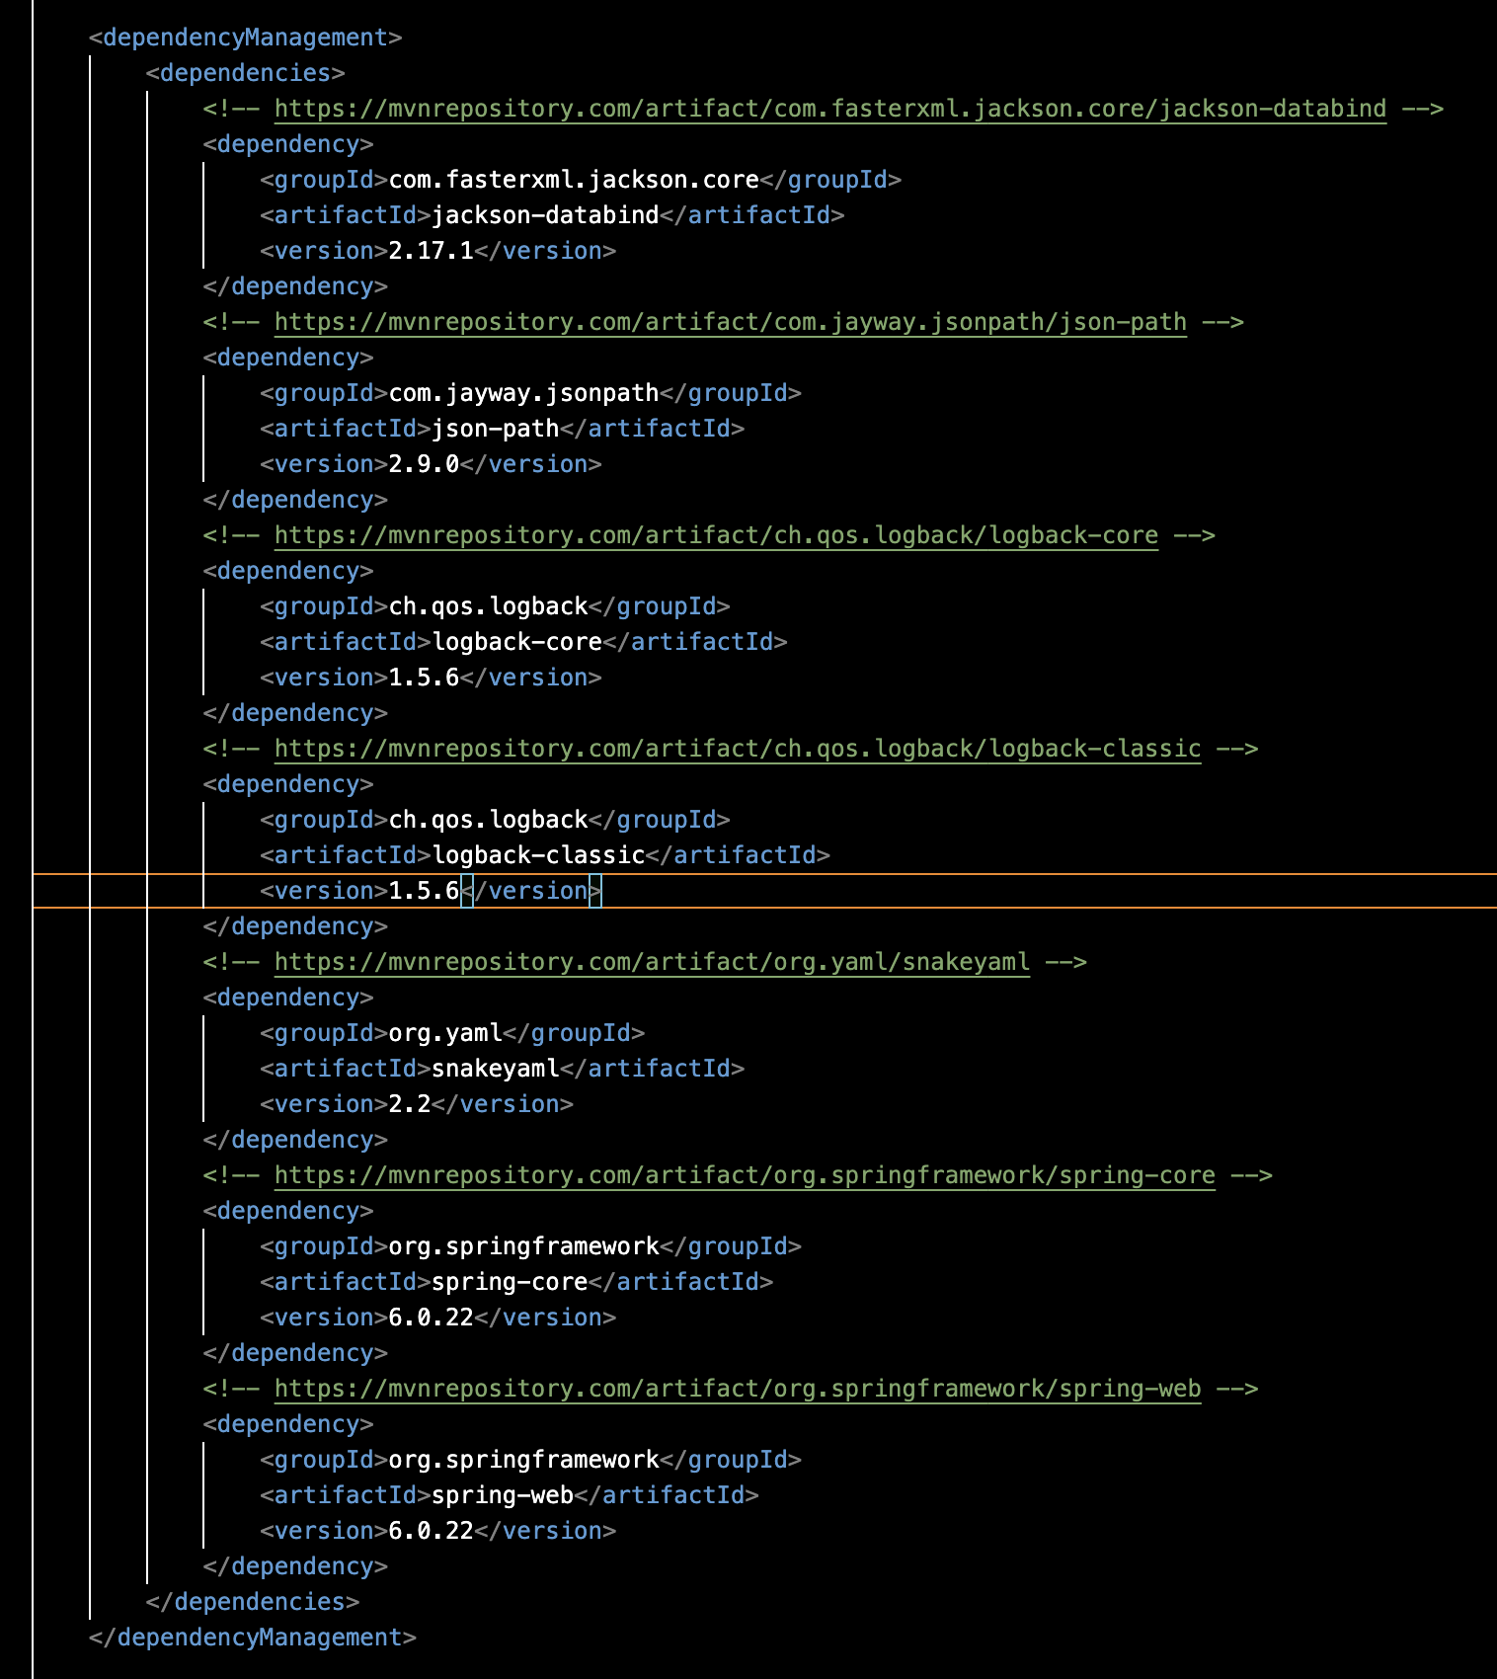

Updated Dependency-Check HTML showing 0 vulnerabilities after updating all dependencies:

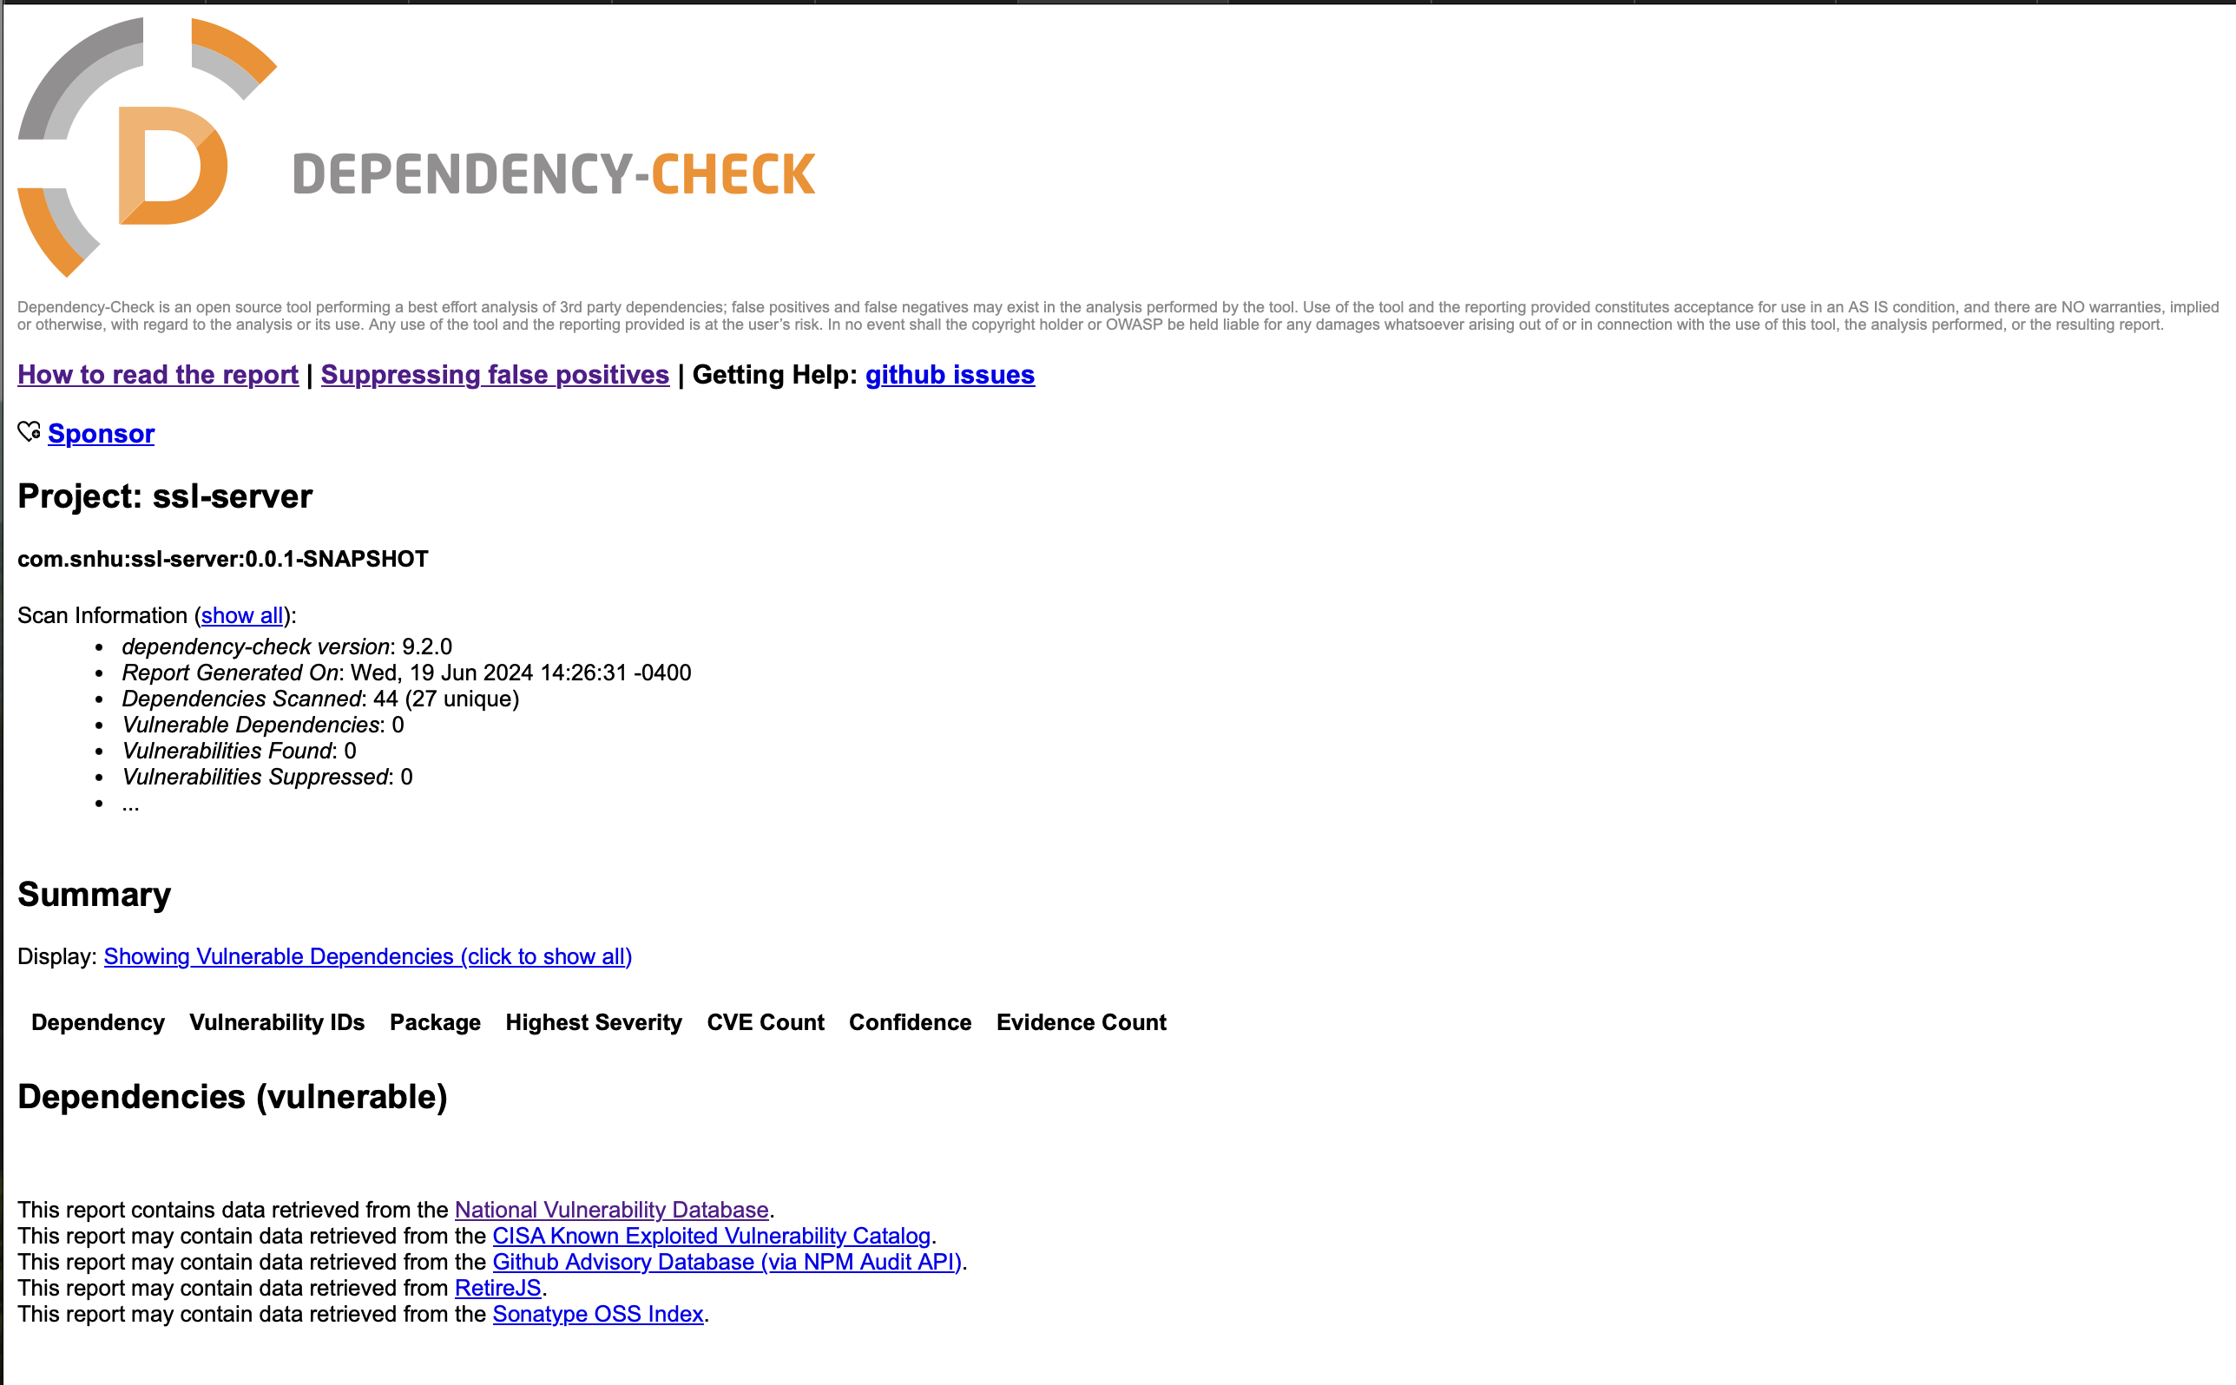

Refactored SslServerApplication.java with updated dependencies running in Terminal:

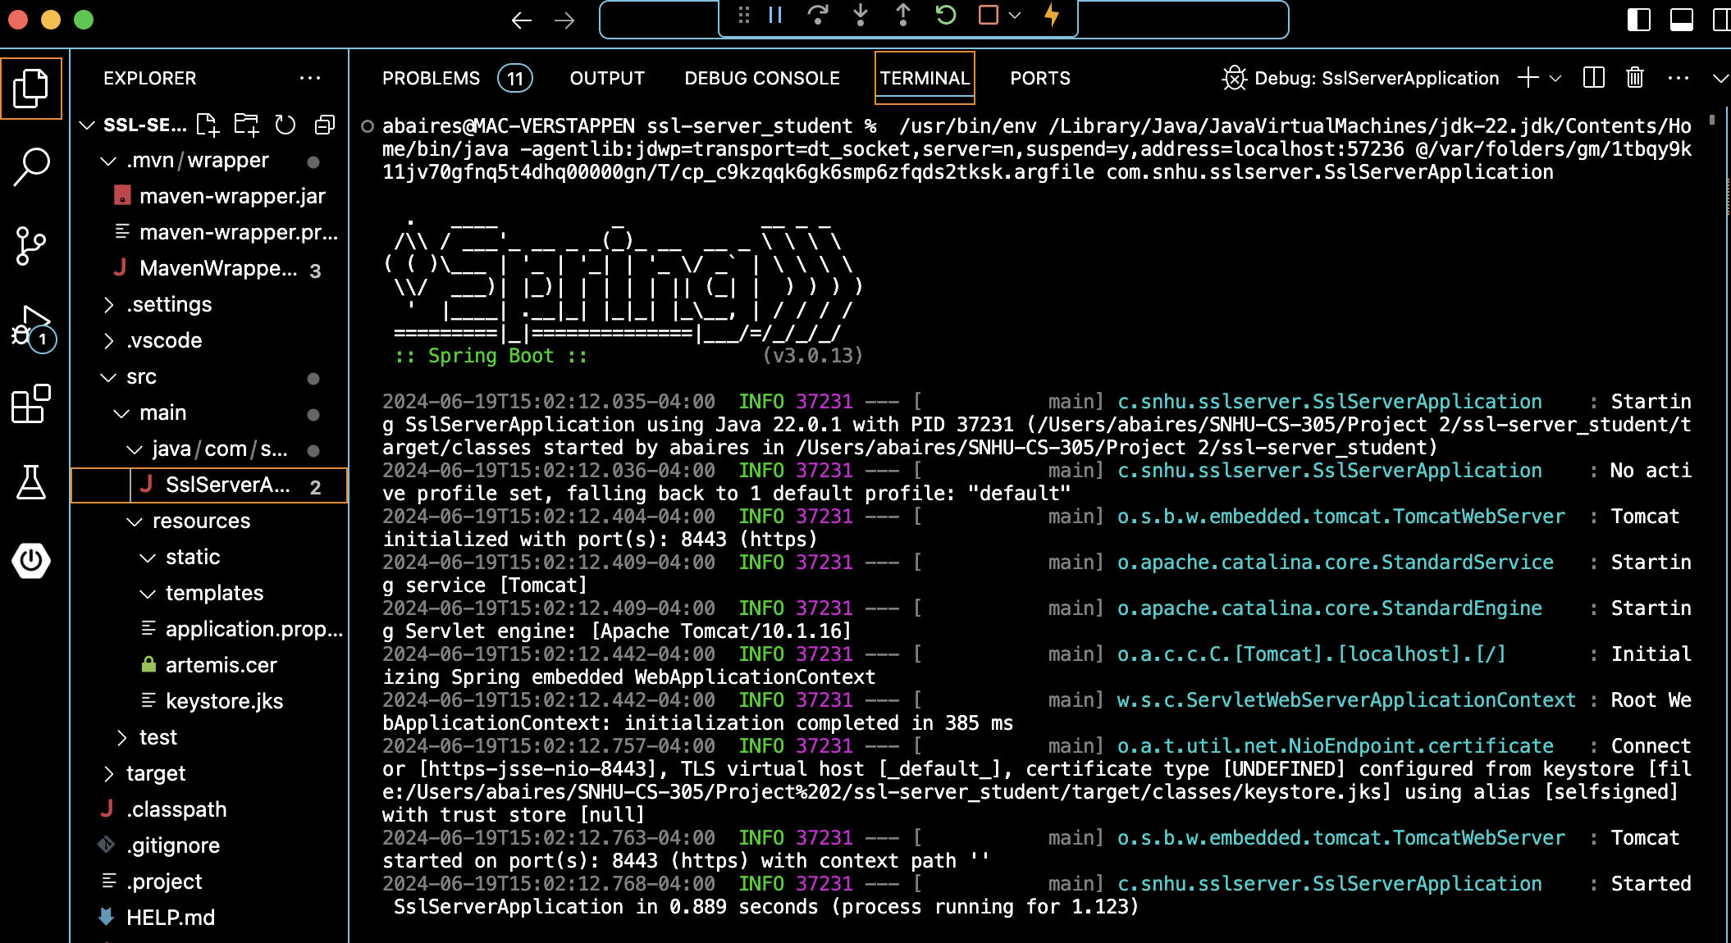

## Functional Testing

Insert a screenshot below of the refactored code executed without errors.

Refactored SslServerApplication.java:

Implemented a logger, used StringBuilder with String.format to prevent insecurities with toHexString().

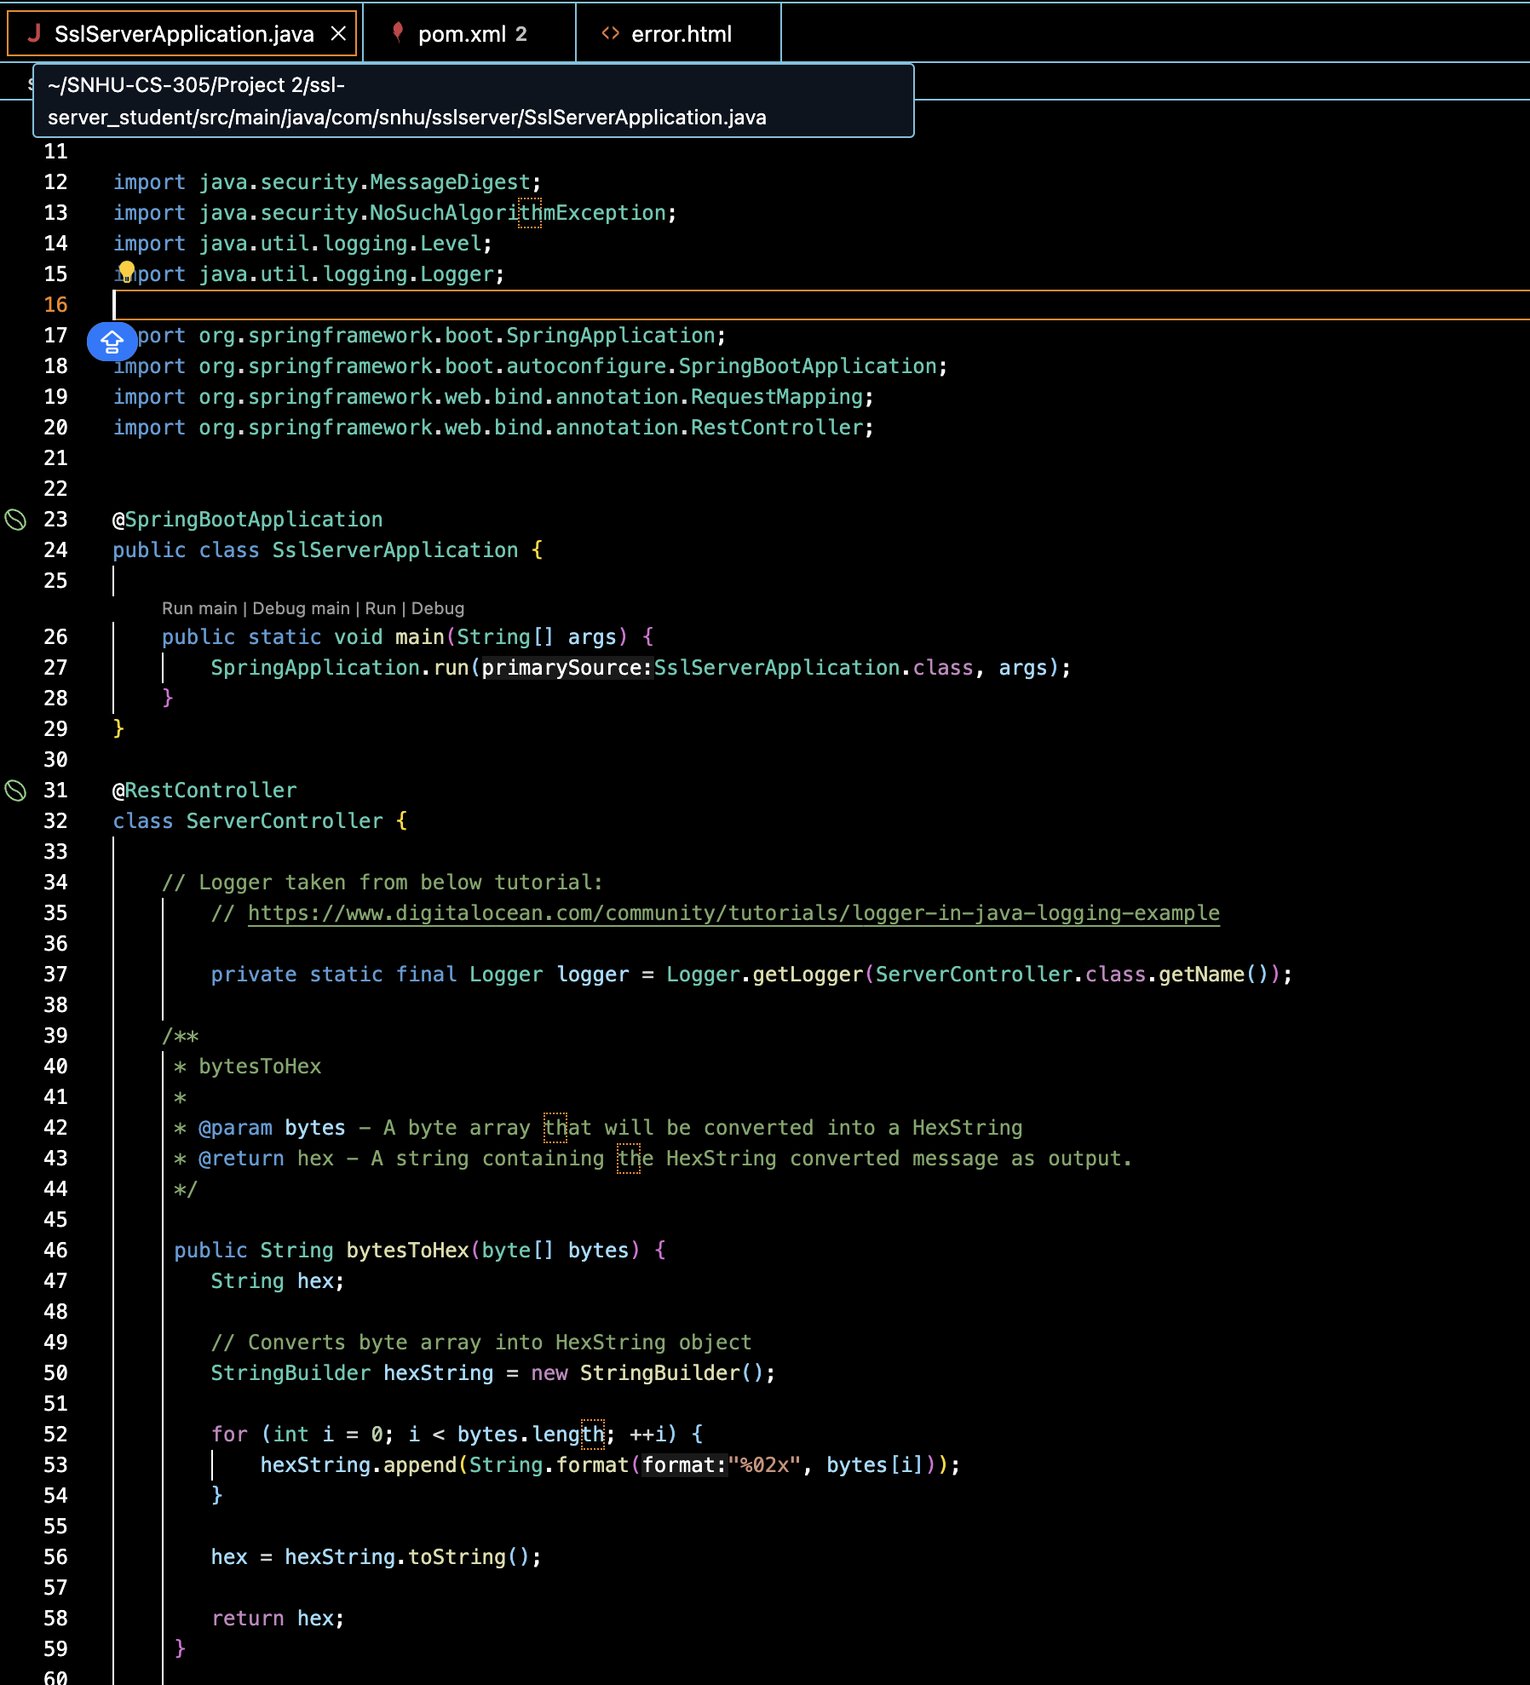

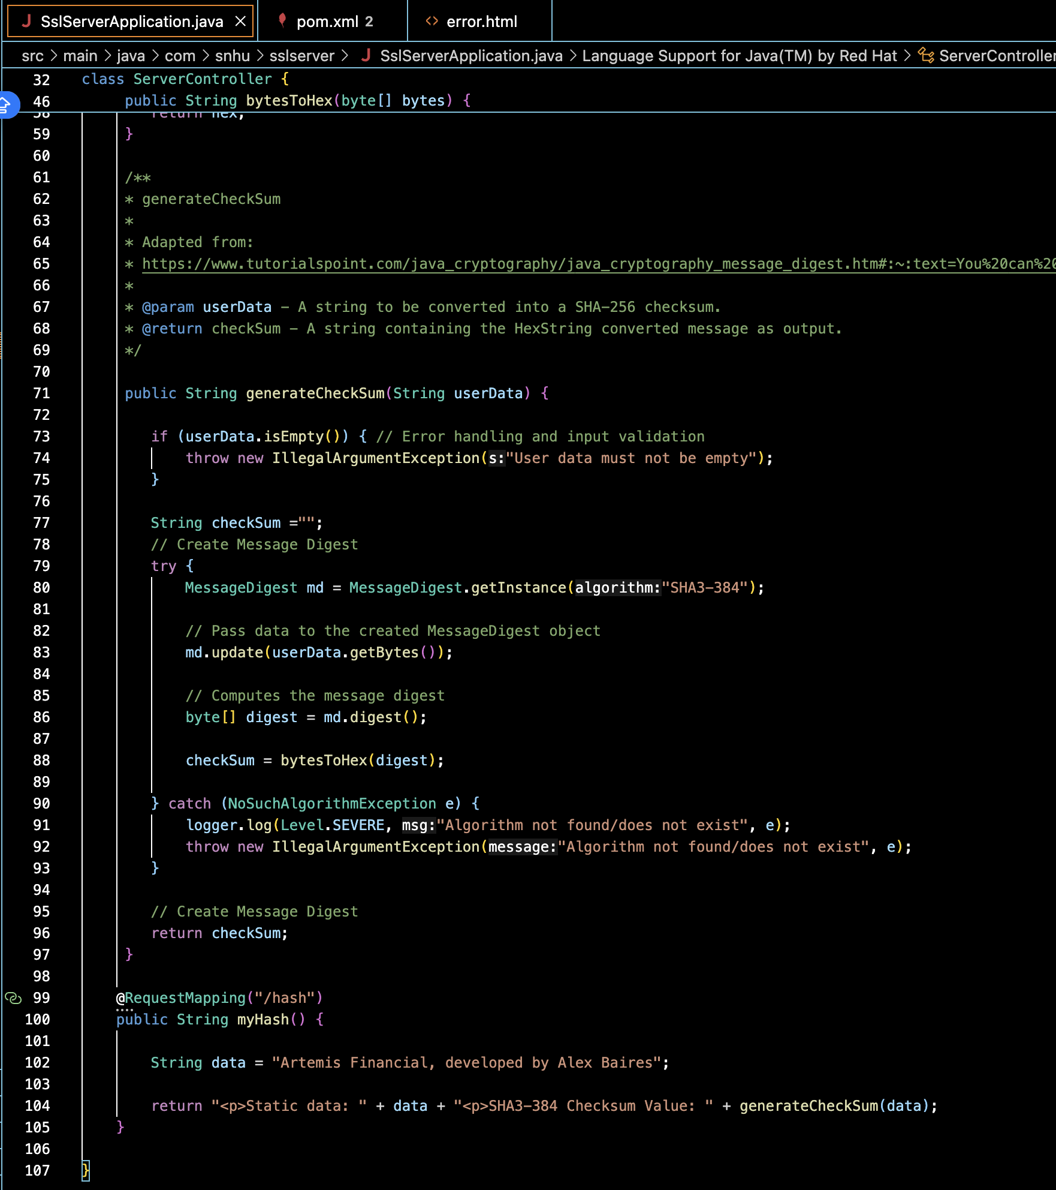

Updated pom.xml to use the latest version of the Thymeleaf dependency, a server-side Java template engine:

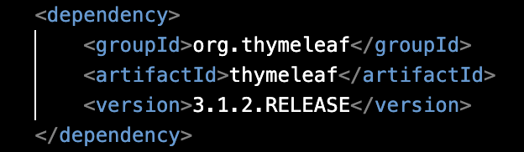

Added error.html template to create a custom web page if the algorithm fails or a user attempts to access an unmapped page:

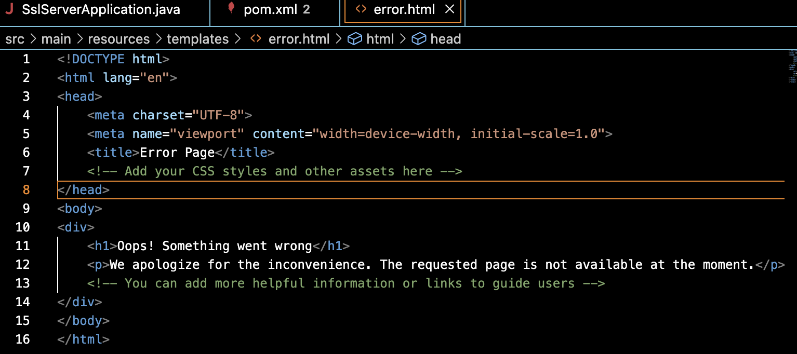

SslServerApplication.java running without errors:

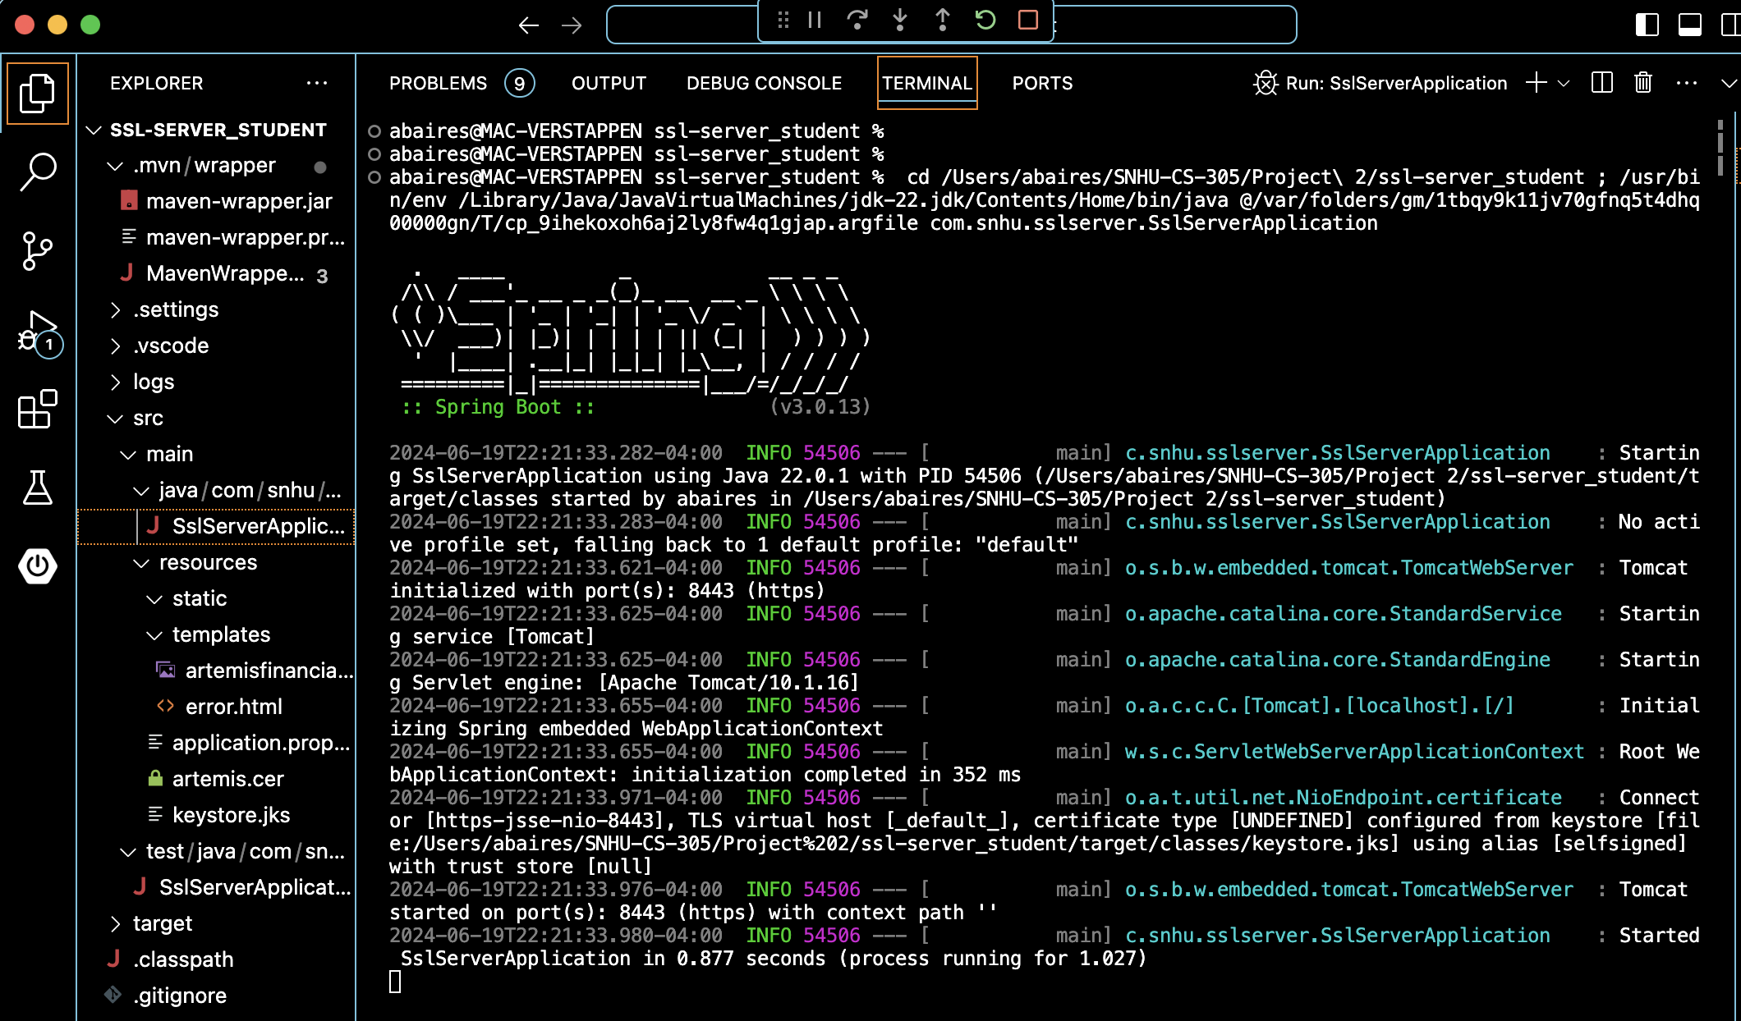

## Summary

When refactoring SslServerApplication.java, I initially created a ServerController class that acts as a REST controller to handle REST API HTTP requests like “/hash.” This falls under “Secure API Interactions” in the Vulnerability Assessment Process Flow diagram.

## Industry Standard Best Practices

[Insert text.]

**References**

Akiya, Y., Le, K. T., Luong, M., Wilson, J. C., Eddin, A. S., Formicola, V., & El-Hadedy, M. (2021). *SHA-3-LPHP: Hardware Acceleration of SHA-3 for Low-Power High-Performance Systems*. 2021 IEEE International Symposium on Software Reliability Engineering Workshops (ISSREW), Software Reliability Engineering Workshops (ISSREW), 2021 IEEE International Symposium on, ISSREW, 393–398. <https://doi-org.ezproxy.snhu.edu/10.1109/ISSREW53611.2021.00107>

Anand, A. (2021, December 12). *Breaking down : SHA-3 Algorithm - InfoSec write-ups.* Medium. <https://infosecwriteups.com/breaking-down-sha-3-algorithm-70fe25e125b6>

*Cryptography Concepts*. (2024, May 7). IBM I. Retrieved June 18, 2024, from https://www.ibm.com/docs/en/i/7.5?topic=cryptography-concepts

Grimes, R. (2018, February 21). *Why aren’t we using SHA-3?* CSO Online. <https://www>.csoonline.com/article/564619/why-arent-we-using-sha3.html

Huang, S., Agmon Ben-Yehuda, O., Dunkelman, O., & Maximov, A. (2022, September 9). *Finding collisions against 4-round SHA3-384 in practical time.* https://eprint.iacr.org/2022/194.pdf.

Manico, J., & Detlefsen, A. (2014). *Iron-Clad Java: Building secure web Applications.* Oracle Press. http://dl.acm.org/citation.cfm?id=2826076